Exploring Heights

2017-11-16

### Introduction

This document summarises provides an initial analysis of height data from the 1990s, as sourced from (HopeCollege 2017).

### Summary of the Data

The data has 100 observations, with the following summary table:

Summary of Heights Data

|  |  |  |  |  |
| --- | --- | --- | --- | --- |
| Gender | Mean | Median | SDev | Number |
| Female | 66.40 | 67.0 | 2.920721 | 50 |
| Male | 72.42 | 72.5 | 2.665655 | 50 |

### Visualisation

The first graphs shows the two cohorts.

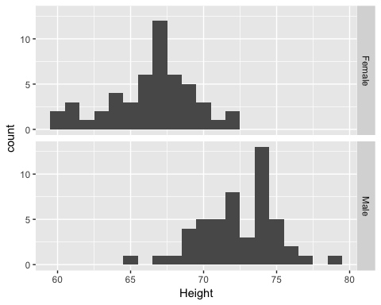

We then show the two cohorts in a single graph.

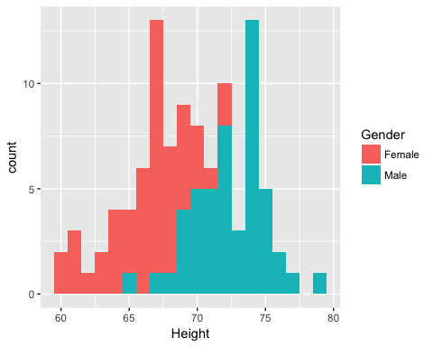

### Statistical Test

Finally, a student-t test is performed on the two data sets, confirming the statistical difference.

##   
## Welch Two Sample t-test  
##   
## data: males and females  
## t = 10.765, df = 97.193, p-value < 2.2e-16  
## alternative hypothesis: true difference in means is not equal to 0  
## 95 percent confidence interval:  
## 4.910132 7.129868  
## sample estimates:  
## mean of x mean of y   
## 72.42 66.40

### References

HopeCollege. 2017. “Data Set from Hope College on Student Heights.” <http://www.math.hope.edu/swanson/data/heights.txt>.